Ermac Voxel Game v 30 (ARCTIC)
“NEWGEN”
Game name: “Demolition Synergy”

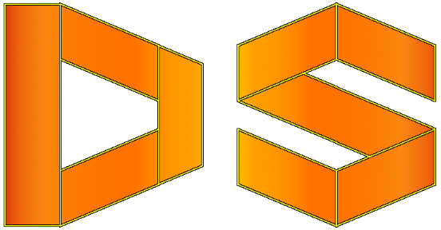

[ARCTIC]
FEATURES:
- Position command (GET Current Position & Chunk,
SET Current Position OR SET Chunk).
- SizeOf command - without arguments provides total size and with chunk argument id provides size of blocks inside chunk (available only as GET).
- Seed number can be provided to Random Level Generator.

CHANGES:
- Shader rework. Moved stuff to the Vertex from the Fragment shader. Lighting reworked.

FIXES:

